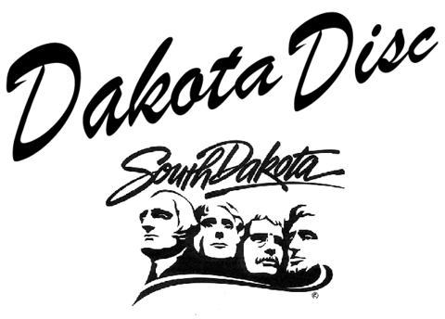Pricing Guide
Basic package: 4 CD-ROMs (1 sent each quarter) of all South Dakota case law, statutes, session laws, court rules, jury instructions and forms. Fastcase membership for one year for up to the minute research in all 50 states for case law, statutes, and regulations.
Price: $500.00 plus tax
Additional disc: $50.00 per disc.
Additional Fastcase attorney subscription: $75.00 per year.
Additional Fastcase non-attorney subscription: $25.00 per year.

Site License: license to upload disc onto server so that all employees can access the contents and access for all employees to Fastcase
Price: $1,500.00

